# STEP 1 : SET UP VCP

Go to Services > VCP

Click on Start VCP Wizard

Choose VPC with Public and Private Subnets, then select

Give names to fields surrounded in blue

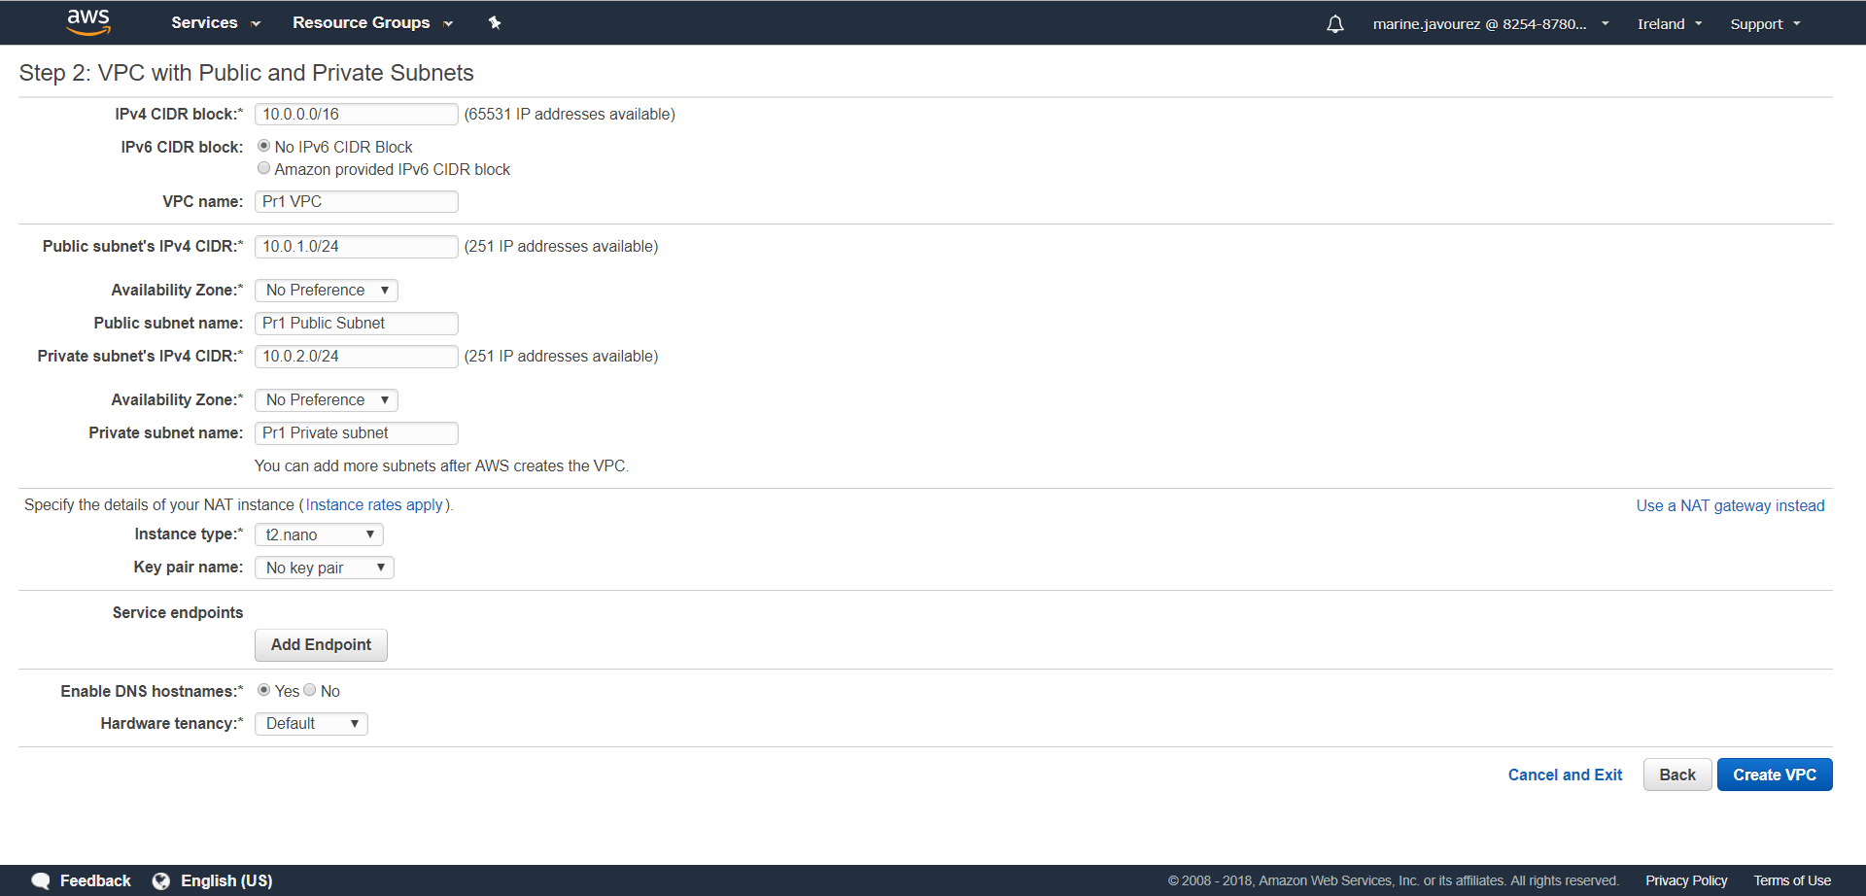

**Click**

**Create VPC**

In Route Tables, name route table with main to yes as private and the other one as public

In Internet Gateways, name the Internet Gateway created

# STEP 2 : SET UP SECURITY GROUPS

To create public security group

Go Security Groups > Create security Group

Fill names to fields surrounded in blue

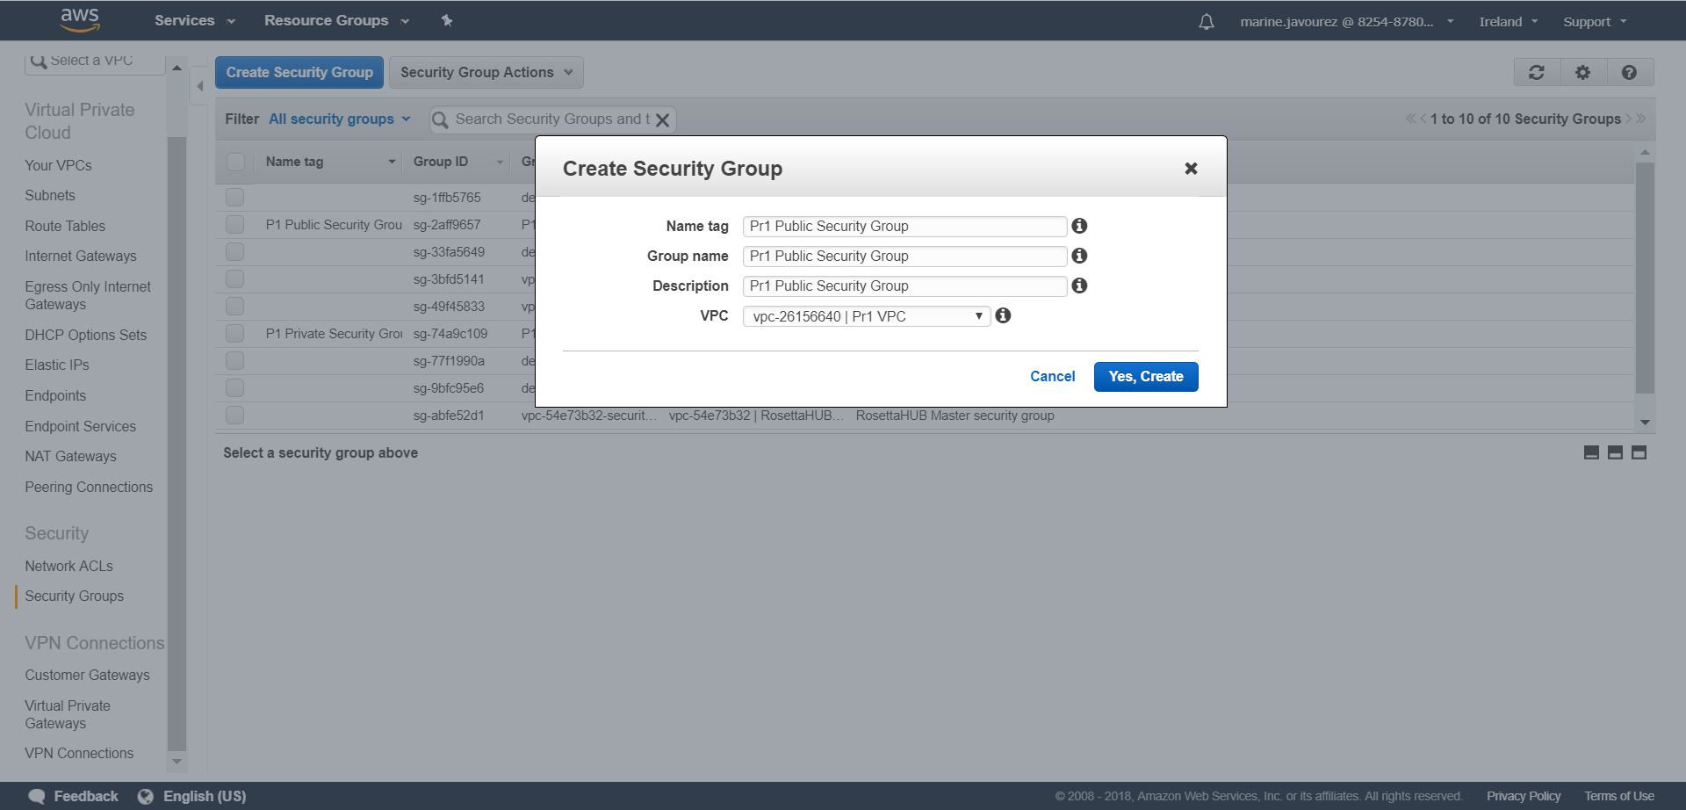

**Select**

**Click**

Select the public security group, tab Inbound Rules

Edit

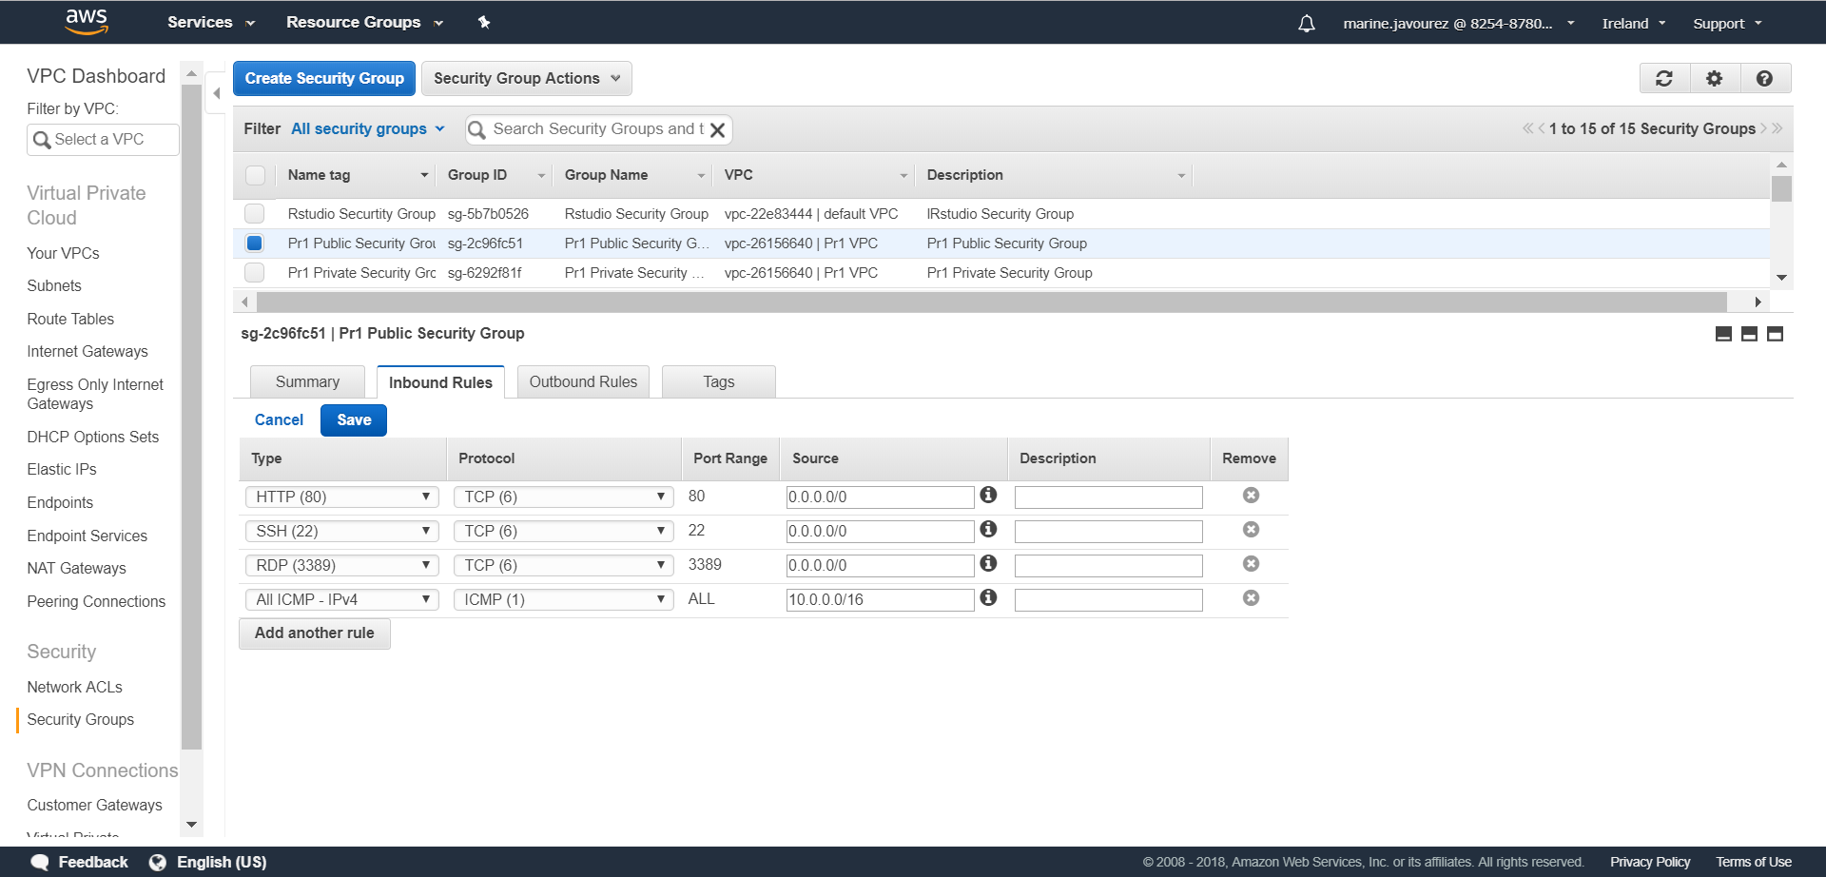

Fill those 3 rules with 0.0.0.0/0 in source

Fill these rule with IPv4 CIDR of your VPC

Save

To create private security group

Go Security Groups > Create security Group

Fill names to fields surrounded in blue

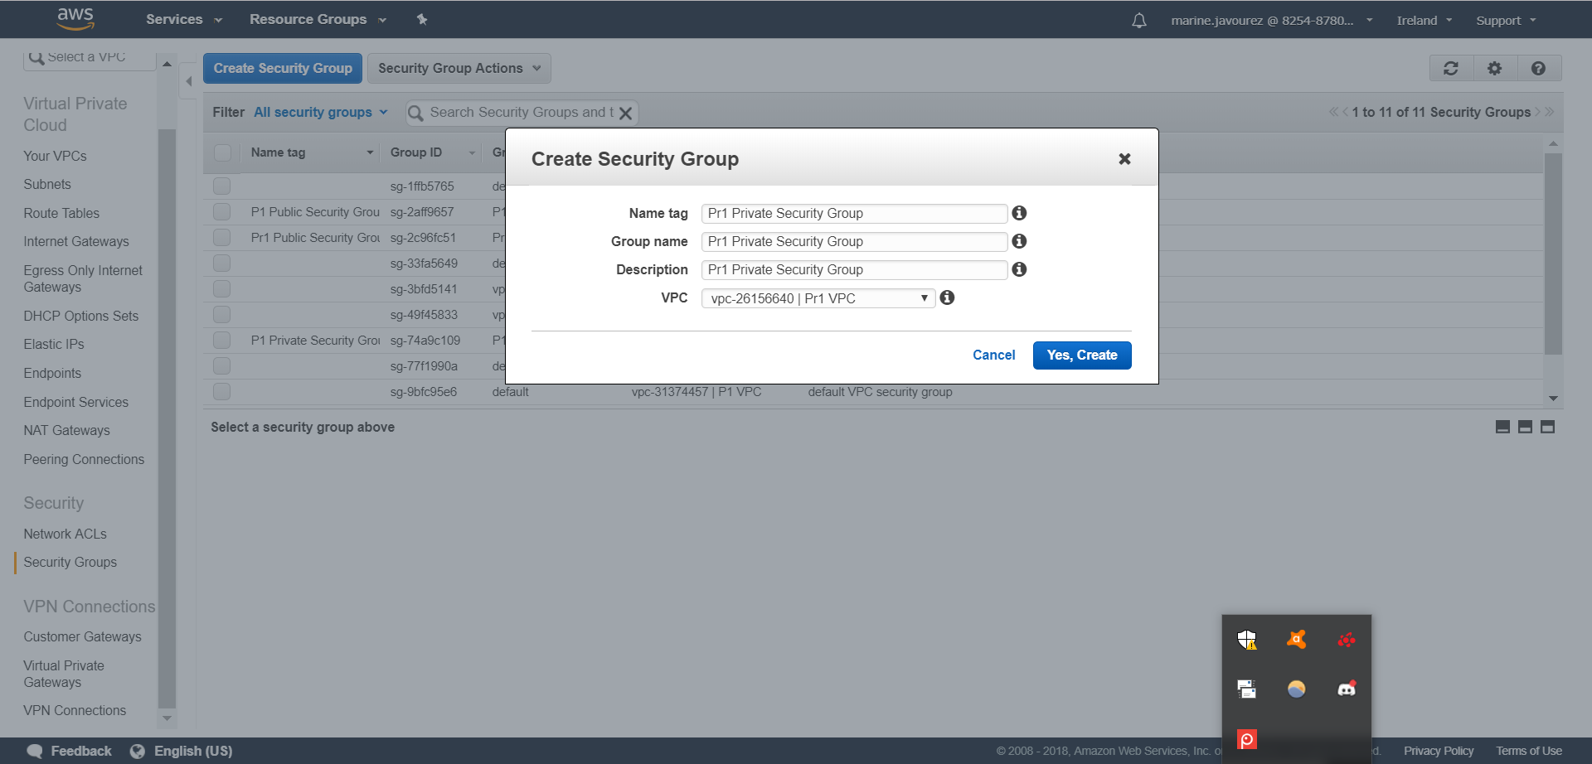

**Click**

**Select**

**VPC**

Select the private security group, tab Inbound Rules

Edit

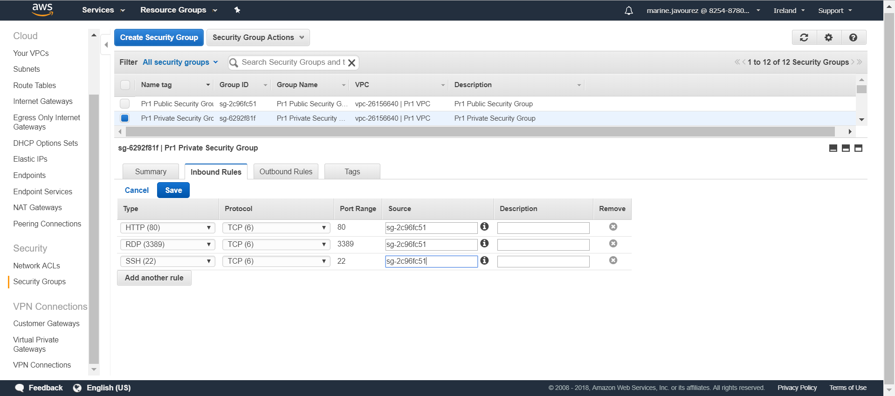

Fill those 3 rules with Public Security Group ID in source

Save

Route tables

Name public and private route table

In private route table / tab Subnet Associations

Edit

Choose private Subnet

Save

Services > EC2

Name new instance as « NAT »

Action > Networking > Change Security Groups

Select the public one

Assign Security Groups

# STEP 3 : SET UP BASTION AND PRIVATE SERVER

Launch Instance

Select Microsoft Windows Server 2016 Base

Choose an Instance Type then Next

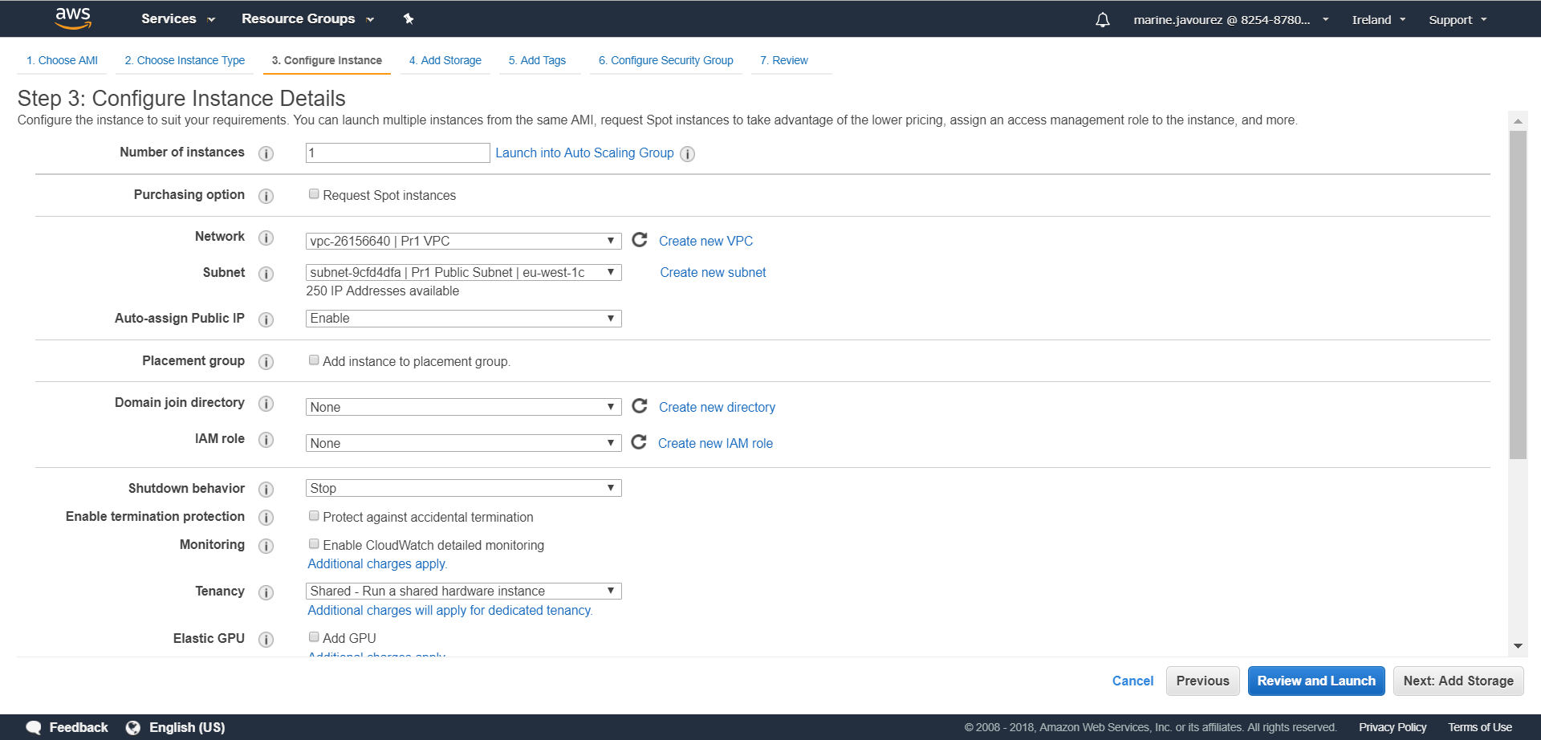

**Click**

**Select Enable**

**Select Public Subnet**

**Select VPC**

Next

Next

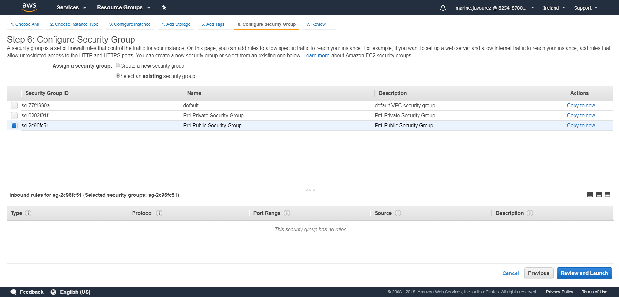

**Click**

**Select Public Security Group**

**Select an existing security group**

Launch

View Instances

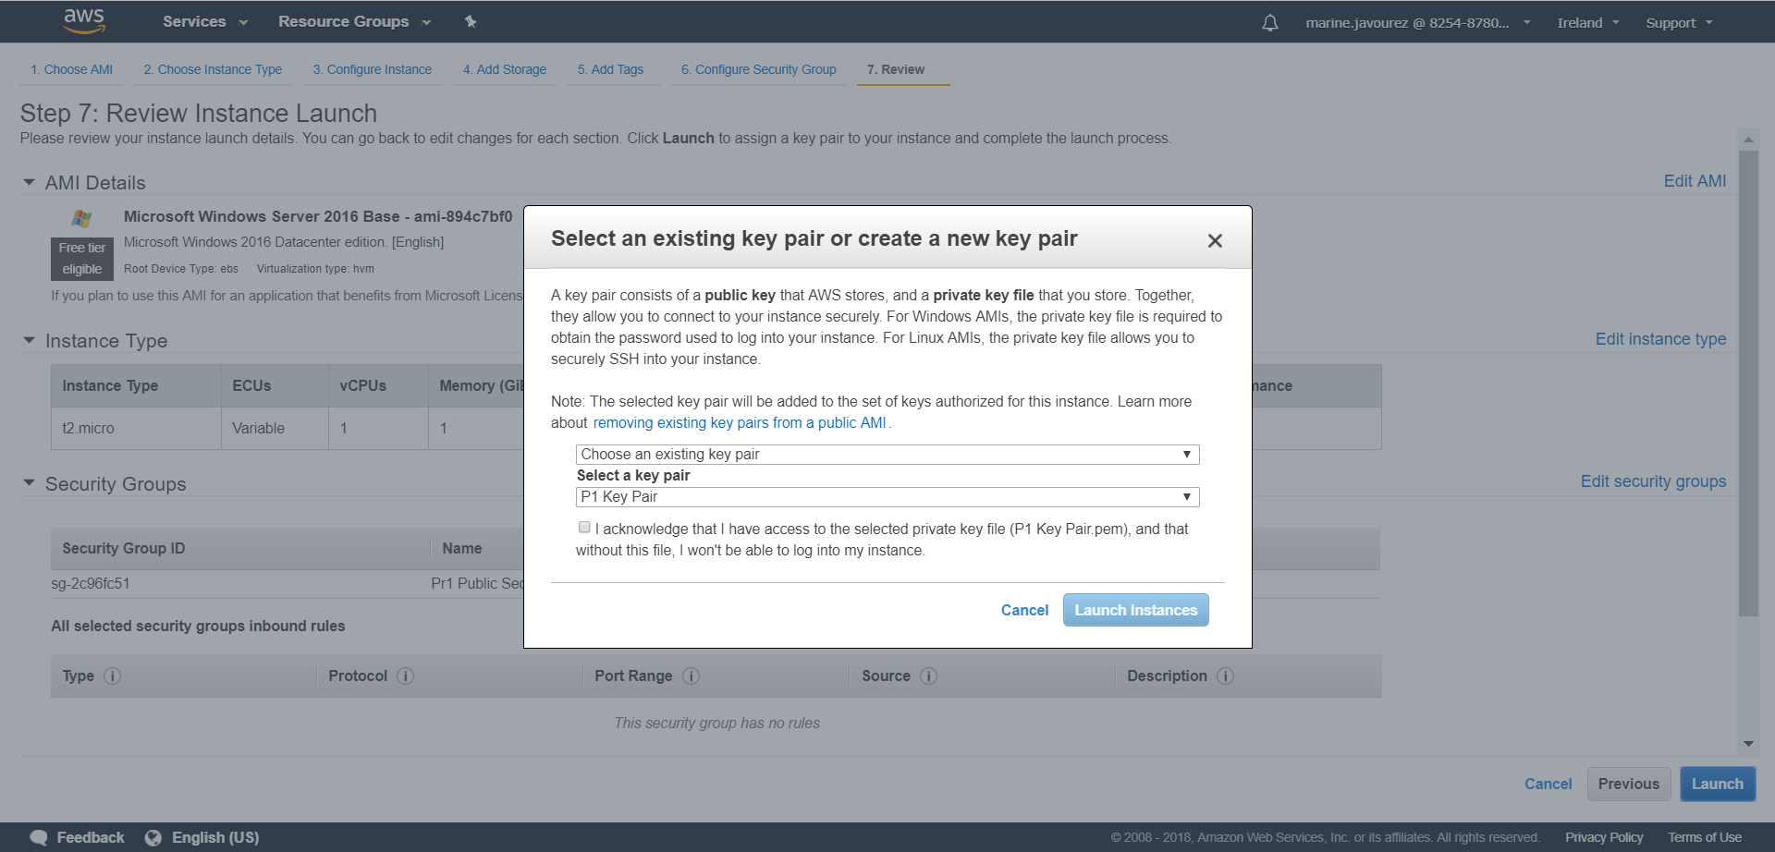

**Click**

**Click**

In Instances, name the instance created as « Web / Bastion »

Launch Instance

Select Microsoft Windows Server 2016 Base

Choose an Instance Type then Next

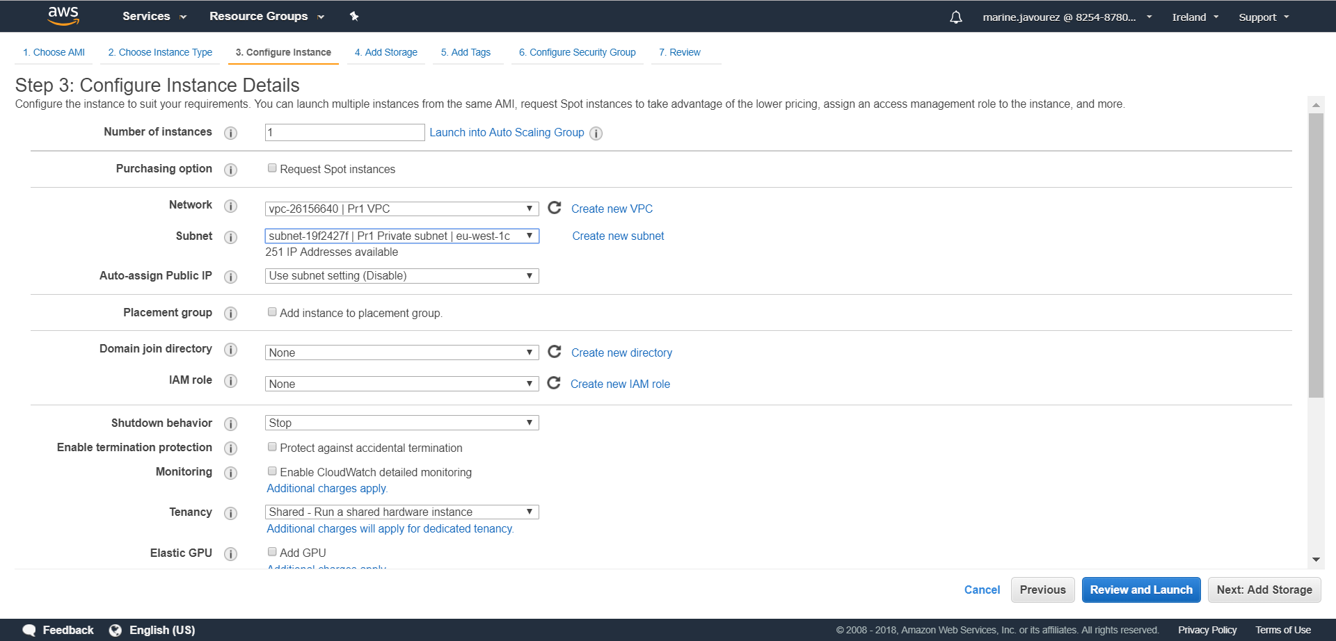

**Click**

**Select Private Subnet**

**Select VPC**

Next

Next

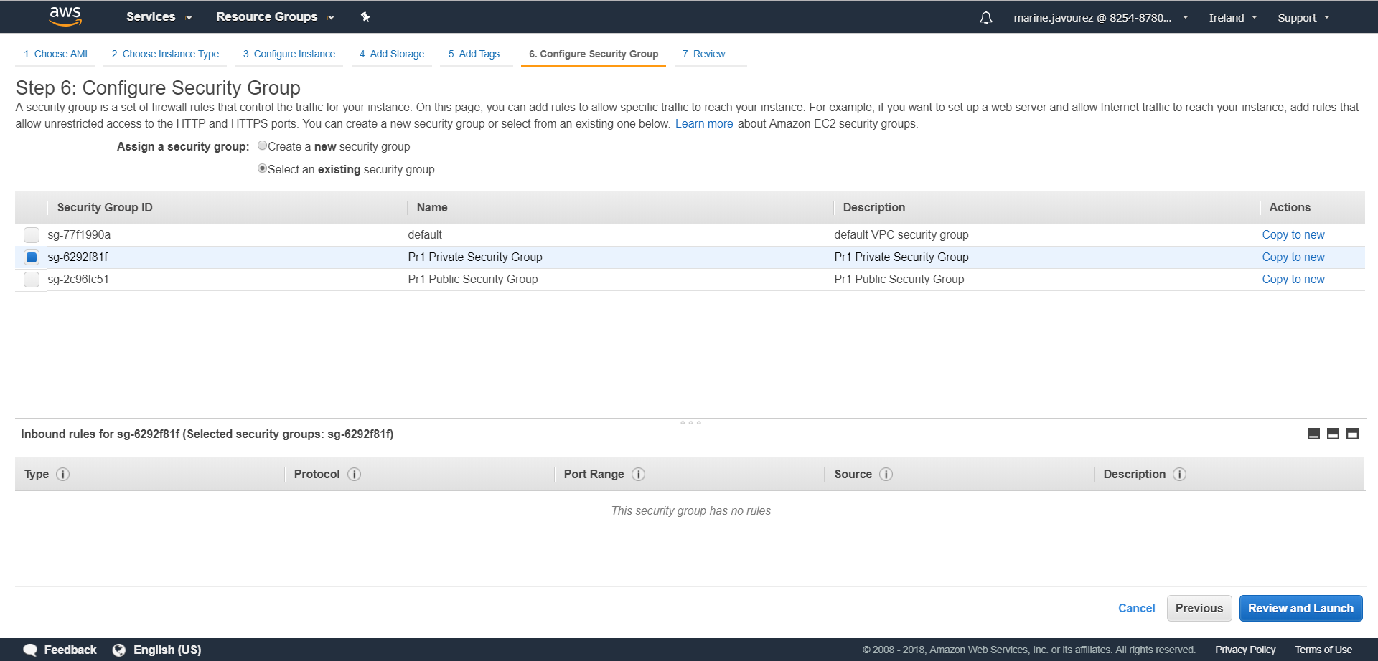

**Click**

**Select an existing security group**

**Select Private Security Group**

Launch

View Instances



**Click**

**Click**

In Instances, name the instance created as Private Server

# STEP 4 : ACCESS TO PRIVATE SERVER

Services > EC2

Select Bastion

Connect

Get password

Decrypt password

Download Remote Desktop File

Open Remote Desktop File inside Bastion server

Select Private instance in AWS console

Connect

Get password

Decrypt password

Enter private ID and password inside Remote Desktop File inside Bastion server

Open cmd

Type ping 8.8.8.8